**CodeNect: Visual Programming Software for Learning Fundamentals of Programming**

An Undergraduate Thesis

Submitted to the Faculty of the

College of Engineering and Information Technology

Cavite State University

Indang, Cavite

In partial fulfilment

of the requirements for the degree

Bachelor of Science in Information Technology

**Lim-it, Brandon B.,**

**Punay, Jaykel O.**

November 2020

1

**Table of Contents**

|  |  |
| --- | --- |
|  | **Page** |
| **Introduction** | **3** |
| Background of the Study . . . . . . . . . . . . . . . . . . . . . . . . . . . . . . . | 3 |
| Statement of the Problem . . . . . . . . . . . . . . . . . . . . . . . . . . . . . . . | 4 |
| Objectives of the Study . . . . . . . . . . . . . . . . . . . . . . . . . . . . . . . . | 5 |
| Significance of the Study . . . . . . . . . . . . . . . . . . . . . . . . . . . . . . . | 6 |
| Conceptual Framework . . . . . . . . . . . . . . . . . . . . . . . . . . . . . . . . | 7 |
| Time and Place of the Study . . . . . . . . . . . . . . . . . . . . . . . . . . . . . | 8 |
| Scope and Limitations . . . . . . . . . . . . . . . . . . . . . . . . . . . . . . . . | 8 |
| Definition of Terms . . . . . . . . . . . . . . . . . . . . . . . . . . . . . . . . . . | 11 |

|  |  |
| --- | --- |
| **Review of Related Literature** | **12** |
| Haxe . . . . . . . . . . . . . . . . . . . . . . . . . . . . . . . . . . . . . . . . . . | 12 |
| Context Diagram . . . . . . . . . . . . . . . . . . . . . . . . . . . . . . . . . . . | 13 |
| Data Flow Diagram . . . . . . . . . . . . . . . . . . . . . . . . . . . . . . . . . . | 13 |
| Gantt Chart . . . . . . . . . . . . . . . . . . . . . . . . . . . . . . . . . . . . . . | 14 |
| Ishikawa Diagram . . . . . . . . . . . . . . . . . . . . . . . . . . . . . . . . . . . | 14 |

ISO/IEC/IEEE 29119-4:2015 Software and systems engineering — Software testing 15

|  |  |
| --- | --- |
| User Interface and User Experience . . . . . . . . . . . . . . . . . . . . . . . . . | 15 |
| Visual Programming Language . . . . . . . . . . . . . . . . . . . . . . . . . . . . | 16 |
| V-Model Process . . . . . . . . . . . . . . . . . . . . . . . . . . . . . . . . . . . | 17 |
| Six Learning Barriers in End-User Programming Systems . . . . . . . . . . . . . | 18 |
| End-User Programming Approaches . . . . . . . . . . . . . . . . . . . . . . . . . | 19 |
| Gulf of Execution and Evaluation . . . . . . . . . . . . . . . . . . . . . . . . . . . | 20 |
| Difficulty in Learning Programming . . . . . . . . . . . . . . . . . . . . . . . . . . | 20 |
| Software Visualization . . . . . . . . . . . . . . . . . . . . . . . . . . . . . . . . | 21 |
| Visual Learning . . . . . . . . . . . . . . . . . . . . . . . . . . . . . . . . . . . . | 22 |
| Visual Programming Software . . . . . . . . . . . . . . . . . . . . . . . . . . . . | 23 |
| Visual Programming vs. Text-based Programming . . . . . . . . . . . . . . . . . | 24 |
| Prototype of Visual Programming Environment for C Language Novice Programmer | 25 |
| On the Design of a Generic Visual Programming Environment . . . . . . . . . . . | 25 |
| Environment pi J for Visual Programming in Java . . . . . . . . . . . . . . . . . . | 26 |
| HASKEU: An editor to support visual and textual programming in tandem . . . . . | 26 |
| The Scratch Programming Language and Environment . . . . . . . . . . . . . . . | 27 |
| **Methodology** | **28** |
| **References** | **32** |
| **Appendices** | **35** |

|  |  |  |
| --- | --- | --- |
|  |  | 2 |
| **List of Figures** | |  |
|  |  | **Page** |
| 1 | Conceptual Framework . . . . . . . . . . . . . . . . . . . . . . . . . . . . . | 8 |
| 2 | V-Model Figure . . . . . . . . . . . . . . . . . . . . . . . . . . . . . . . . . | 30 |
| 3 | Respondents’ Course . . . . . . . . . . . . . . . . . . . . . . . . . . . . . . | 40 |
| 4 | Respondents’ Grade/Year Level . . . . . . . . . . . . . . . . . . . . . . . . | 40 |
| 5 | Desired technology field to Work in . . . . . . . . . . . . . . . . . . . . . . . | 41 |

* Known programming before Entering College . . . . . . . . . . . . . . . . . 41

7 Number of Years Programming . . . . . . . . . . . . . . . . . . . . . . . . . 42 8 Programming Languages Comfortable With . . . . . . . . . . . . . . . . . . 42

|  |  |  |
| --- | --- | --- |
| 9 | Method of Education . . . . . . . . . . . . . . . . . . . . . . . . . . . . . . | 42 |
| 10 | Hard to Learn in Programming . . . . . . . . . . . . . . . . . . . . . . . . . | 43 |
| 11 | Text-based Editing Tool Used . . . . . . . . . . . . . . . . . . . . . . . . . . | 43 |
| 12 | Alternative Method . . . . . . . . . . . . . . . . . . . . . . . . . . . . . . . | 43 |
| 13 | Ease of Usage with Text-based Editors . . . . . . . . . . . . . . . . . . . . | 44 |

1. Understanding Programming Fundamentals . . . . . . . . . . . . . . . . . . 44
2. Respondents’ Programming Knowledge Assessment . . . . . . . . . . . . . 44

|  |  |  |
| --- | --- | --- |
| 16 | Ishikawa Diagram 1 . . . . . . . . . . . . . . . . . . . . . . . . . . . . . . . | 45 |
| 17 | Ishikawa Diagram 2 . . . . . . . . . . . . . . . . . . . . . . . . . . . . . . . | 46 |
| 18 | Ishikawa Diagram 3 . . . . . . . . . . . . . . . . . . . . . . . . . . . . . . . | 47 |

1. Context Diagram of Existing System . . . . . . . . . . . . . . . . . . . . . . 48
2. Context Diagram of Proposed System . . . . . . . . . . . . . . . . . . . . . 48

|  |  |  |
| --- | --- | --- |
| 21 | Gantt Chart . . . . . . . . . . . . . . . . . . . . . . . . . . . . . . . . . . . | 49 |
| 22 | Theoretical Framework . . . . . . . . . . . . . . . . . . . . . . . . . . . . . | 50 |

**List of Appendices**

|  |  |
| --- | --- |
| Appendix A - Survey and Assessment Forms . . . . . . . . . . . . . . . . . . . . | 35 |
| Appendix B - Graphical Results . . . . . . . . . . . . . . . . . . . . . . . . . . . | 40 |
| Appendix C - Ishikawa Diagrams . . . . . . . . . . . . . . . . . . . . . . . . . . . | 45 |
| Appendix D - Context Diagrams . . . . . . . . . . . . . . . . . . . . . . . . . . . | 48 |
| Appendix E - Gantt Chart . . . . . . . . . . . . . . . . . . . . . . . . . . . . . . . | 49 |
| Appendix F - Theoretical Framework . . . . . . . . . . . . . . . . . . . . . . . . . | 50 |

3

**CodeNect: Visual Programming Software for Learning**

**Fundamentals of Programming**

**Lim-it, Brandon B.,**

**Punay, Jaykel O.**

An undergraduate thesis outline submitted to the faculty of the De-partment of Information Technology, College of Engineering and Infor-mation Technology, Cavite State University, Indang, Cavite, in partial fulfillment of the requirements for the degree of Bachelor of Science in Information Technology. Pre-pared under the supervision of Mr. James Angelo V. Aves

**INTRODUCTION**

As the innovation in technology is continuously making its progress in improving the quality of life. With this nature of technology comes the essential need for programming skill as core profiency. The competition in the field that developers and programmers alike strive for is becoming harder to get into due to high standards and requirements. One of the requirements for a programmer and developer is to have expertise in technical skills that include multiple programming languages (Tsai, Yang, and Chang, 2015). Without the proper knowledge and understanding in programming in its fundamental level and depth, one will find it difficult to adapt to the constantly shifting world of computer.

Improving learning without prolonging the time allotted in each academic year needs to focus on enhancing the properties of the software that are both utilized as teach-ing and learning tools by the instructor and the student. A system that is implemented using modern tools, industry standard design, and functionality that focuses in simplicity, readability, and learning experience. Modern technology increases the rate of knowledge acquisition and absorption through its usage and implementation in education (Raja and Nagasubramani, 2018). The advancement in technology greatly contributes to education

4

as it enables convenience in communication and presentation of knowledge and informa-tion almost instantaneously (Anggrawan, Ibrahim, M., and Satria, 2016). A software that prioritize functionality over unnecessary features to ensure that the user is not overloaded with information in the screen that is unnecessary. Users perceive numerous features in a product to be useful and engaging but such can result in fatigue (Thompson, Hamilton, and Rust, 2005).

Software with the necessary tools and functionalities oriented towards learning purposes and is also designed to and packaged with coding exercises and problems which range from beginner, intermediate, to advance difficulties is not popular and lacking in avail-ability. Features that are carefully selected and designed towards showing and comparing various solutions that are working in the context that they meet the requirements and out-put and are technically correct, but not all will meet the standard when it comes to better quality which is the advantages in skills acquired when mastering the fundamentals of pro-gramming. This approach in problem solving allows learners to develop logical and critical thinking through the application of the theory of variation, wherein some aspects that are critical must vary while other aspects stay constant (Cheng, 2016). This is effective in the domain of programming as even a slight change in data amounts to a change in effect and output.

Programming is a skill wherein it focuses in the connection of logic rather than memorizing information as that of in other domain, the curve in starting to learn it is steeper compared to actually applying it in real works and mastering it. Mastering a programming language is not an easy task, but in general all share common concepts. Learning by heart these core concepts and fundamental knowledge will help programmers to easily learn and master any existing or new programming language through the reiteration of principles that all programming languages are built and modeled upon. For the design and decision that go behind the creation of new programming languages are reevaluation of existing studies, syntax, semantics, and inspired by widely used and accepted languages (Chang Boon Lee, 2011). For anyone who is new to programming, the topics can be a daunting and intimidating task. Failure in familiarization and application in the early academic years and progressing to the next period wherein advance subjects are covered bereaves the overall learning of the student.

5

**Statement of the Problem**

The fundamental concepts of programming are essential basics that are necessary for programmers to master. Concepts such as syntax, semantics, variables, data types, data structures, logic, conditionals, loops, algorithm, and memory are key to easily understand-ing and getting better at programming as it is a discipline (Prahofer, Hurnaus, Wirth, and Mossenbock, 2007). Programming is a skill which can be boring, intimidating, and unrelated to daily activities and experience. Students are lacking in understanding of the execution of a program (Tan, Ting, and Ling, 2009). Programming education requires the assistance of technology itself through software in improving the quality of learning. The traditional method of pure lecture is nowadays complimented with the application of softwares. But most tools are not beginner-friendly and are cluttered with features that present confusion and steep learning curve in familiarity and mastery that diminish the learning experience (Tsukamoto et al., 2016).

The assessment of the respondents under the courses with programming subjects (See Appendix Figure 3) shows that students (See Appendix Figure 15) are not familiar and not well versed on fundamental concepts and find it difficult to understand (See Appendix Figure 14). (See Appendix Figure 16).

Basic concepts such as loops, memory management, and functions are easily un-derstood individually, but combining them into a program has confused students (See Ap-pendix Figure 17). Respondents failed to correctly answer the assessment (See Appendix Figure 15).

Survey shows that 76% of students use outdated text-based editors in their labo-ratory classes such as Notepad++, DevC++, and TurboC/C++ (See Appendix Figure 11), while only 24% use professional and modern editors for programming. This traditional text-based editors are general tools and are not oriented for learning of beginners and thus not effective (See Appendix Figure 18).

**Objectives of the Study**

The general objective of the study is to develop a CodeNext: Visual Programming Software that will help in learning the fundamentals of programming.

Specifically, this study seeks to answer the following questions:

1. Identify the concepts learners find difficult to understand through conducted survey.

6

1. Analyze the problems through a Ishikawa/Fishbone Diagram.
2. Design the system using the Use Case Diagrams.
3. Develop the software with the following main features:
   1. Visual Nodes Module handles the core elements and building blocks in the soft-ware for writing logic and code.
   2. Filesystem Module handles the creation, modification, reading, and deletion of files.
   3. Input and Output Module is the interface for user actions such as mouse events and key events and what is displayed to the screen for the user.
   4. Debug Module lints the visual code for errors and warnings before the running the code. It also captures errors and warnings during runtime and report it to the user.
   5. Simulation Module for compiling and running the visual program to a command line program.
   6. Transpiler Module that will convert the visual logic to other programming lan-guages such as C/C++, Java, Python, Javascript, Lua, and more.
   7. Assessment Module that will evaluate the knowledge and learning of the users by providing basic and common coding exercises. Exercises can be imported, shared, and distributed through simple package files.
4. Test and evaluate the usability, functionality, and acceptability of the software.

**Significance of the Study**

The result of the study will be of great benefits to the following:

The software will help in the education and improvement in the knowledge, skills, understanding, and expertise of the students and learners about programming. Thus, al-lowing them to compete and increasing the opportunities for their careers.

The software will provide assistance for teachers and instructors to teach and demo programming concepts through visualization. This will aid in relieving workload, stress, and maximizing lessons each class time.

7

The software will benefit educational institutions like university for computer labo-ratory classes by providing a free software oriented for the purpose of learning.

The software will provide learning experience for the developers and researchers in preparation for software development career.

This study would serve as a guide and reference in the field of software develop-ment and education for future researchers.

**Conceptual Framework**

The conceptual framework (1) represents the relationship and flow of the concept of developing a visual programming software for learning the fundamentals of programming.

It shows the order of actions required by the study to achieve the desired output following the design of the context diagram (20)

The inputs has the following requirements for the development of the study. Knowl-edge requirements include the Haxe programming language, user-interface design, user-experience design, data flow diagram, and context diagram. Software requirement include Linux 5.4 - Manjaro as operating system and distribution, Vim as text and code editor, termi-nal, Kha and zui library for graphics, and the Haxe programming language for development. Microsoft Windows 7 and above, C++ Runtime libraries, and the Haxe programming lan-guage for deployment. Hardware requirement are machine with at at least Intel Core 2 Duo at 1.4 GHz, 2 GB of RAM, and 80 GB HDD storage for development. At least Intel Core 2 Duo at 1.4 GHz, 2 GB of RAM, and at least 1 GB HDD storage space for deployment.

The process to be followed and used for the development of the software is the V model. The process model involves the requirements of gathering necessary data and infor-mation from respondents through conducted survey. High-level design of the implementa-tion of the requirements of its technical usage for system design. Design of the relationships and dependencies of the modules, creation of diagrams, and selection of technology to be used. Preparation of the design and test method for each module. Followed by the coding of the modules and the software. The evaluation is based on the ISO/IEC/IEEE 29119-4.2015, specifically the experience-based test design technique, to assure the functionality, efficiency, usability, portability, and reliability of the software.

The impact expected from the study is the availability of a software designed for learning to program and its fundamentals for learners, students, and educators. Another

8

impact is the improvements in the understanding, skills, and academic performances of the students in the course of programming.

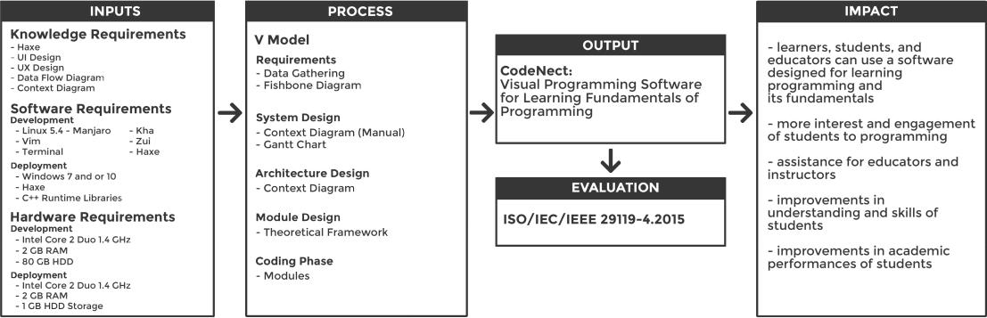

Fig. 1: Conceptual Framework of proposed CodeNect: Visual Programming Software for Learning Fundamentals of Programming

**Time and Place of the Study**

The study started from the approval of the title on the month of February of year 2020. The development is expected to be finished on the month of May of year 2021. The necessary data were gathered through survey and research at the Cavite State University and other information were researched and obtained from the Internet.

**Scope and Limitations of the Study**

The study focuses on the development of a CodeNect: Visual Programming Soft-ware for learning the fundamentals of programming. The software will prioritize simple and basic functionalities over numerous features for the purpose of learning and education.

The software is to be developed in Linux operating system. The source is to be re-leased as open-source with appropriate license to improve contributions. Since the software is stand-alone program, there will be no account management and no access levels.

The software is designed with seven core modules: Visual Nodes Module, Filesys-tem Module, Input and Output Module, Debug Module, Simulation Module, Transpiler Mod-ule, and Assessment Module.

**Visual Nodes Module**

Nodes are graphical elements that serve as the building blocks of the software. Nodes can be used as a variable, logic, and conditionals. The properties of the node are internal randomly generated UUID (Universally Unique Identifier), position, size, and type.

9

The fields of the node that are visible to the users, which can be modified, are name, and value(s). Each node has input socket(s) and output pins which are used for the flow of logic and redirection of data. The visibility of the sockets and pins of a node is dependent on its type. For example, nodes that are constant variables will only enable the output socket as it is read-only, while regular variable nodes allow for both sockets. Nodes are connected to one another through the use of wires. This relation of nodes is called the node graph. The flow of logic is easily determined using the wires with directional arrows signifying the direction of the logic.

**Filesystem Module**

This module serves as the interface between the software and the user’s machine for handling files. The module have four main functionalities, creation, modification, reading of files, and backup. One feature of the software that benefits from this module is the importation of exercises from package format file which allows for more learning materials that greatly increases the possible usage of the software.

When a user starts a new project, a template project structure with base files are created by the module and is saved into the user’s machine. The modules assure that the project is stored with proper permission and in safe location. Modification such as addition or deletion is also handled by the module. The reading of files and project functionality takes into consideration the validity and safeness of the file and handles if the file is corrupted. The backup functionality regularly makes a backup of file in case of emergency such as program crash or user-side accident.

**Input and Output Module**

This module captures user input events such as key press, mouse movement, mouse click, and so on. The module is responsible for processing and responding events and performing actions based on the event. This ensures that the interaction between the user and the software provides rich experience in terms of usability and learning.

This module handles output to the user. File, displays, views, and screens are examples of the possible types of output. The module manages everything that is rendered to the screen for the user to see such as the elements, the visual graph, a combination of the visual nodes connected to each other, the assessment files or reports, and the simulation view.

10

**Debug Module**

This module will linter and give feedback and indication to the user whenever there is an attempt to perform an action that is faulty in logic. For example, the red color means er-ror or danger while the yellow color means warning. The color based feedback and highlight is used in combination with useful messages giving more detailed information regarding the fault. These are placed accordingly to the source of the fault, whether in the node or in the wire. Runtime errors or warnings during the simulation stage is propagated to the user with detailed information and explanations about the probable cause of error and displays tips in debugging and fixing the program.

**Simulation Module**

The process of simulation involves the compiling, building, and running the visual code is executed by this module. The compilation stage involves going from the main node which is the entry point of the program followed by the importing of libraries and packages (depending on the target language). After that is the declaration of variables and methods and will continue to parse and convert the visual code to its equivalent source code.

The compilation stage is followed by the building, also known as linking stage. During this stage, the compiled source code is linked with the necessary libraries required by the target programming language. Examples of this are Dynamic Linking Libraries (.dll) and Shared Objects (.so) files.

After the compilation and building stage is the simulation or execution stage. This executes the program and run it with additional features enabled to allow a more dynamic and intuitive interaction between the user and the program.

**Transpiler Module**

This module transpiles the visual code made by the user into source code in target programming language. This module tests that the transpiled source code compiles and runs correctly as well. This allows for learners to see and compare their work into other programming languages which is part of the education curriculum. This serves as helper for their transition from learning the fundamentals of programming into its application towards programming languages that are more robust, high quality, and industry-standard.

**Assessment Module**

11

The functionality of providing exercises designed for the learning of topics and concepts in programming and evaluation of the results are handled by the Assessment Module. The possible types of exercise range from output-based program to writing an algorithm that has memory and time limitation and complexity. The module can store the evaluated performances or grades of the user for further analyzation and can provide basic reports such as determining what concepts do most students find it difficult to learn within a set of time.

The software is limited to simulating text-based or command/terminal prompts as the priority is learning the fundamentals of programming. The software does not also com-pete as an Integrated Development Environment (IDE). The software does not provide net-working functionalities such as connection to the internet to send or fetch data. There is also no access level or account management for the user.

**Definition of Terms**

**Algorithm** is a set of instructions designed to perform a specific task.

**Bug** is unwanted behavior caused by faulty logic.

**Building** is linking compiled code with libraries to make an executable. **CodeNect** is a visual programming software for learning programming fundamen-

tals.

**Compilation** is turning human-readable language to machine language.

**Conditionals** are statements or expressions comparing logic in programming.

**Data** is information digitally stored in and processed by computer.

**Data Structure** is grouping and storage of data efficiently in memory.

**Data Types** are attributes to determine the size and type of data.

**Debugging** is the process of finding and resolving of bugs in a program.

**Graphical User Interface** is the interface of interactive graphical elements.

**Integrated Development Editor** provides features for easier text programming.

**Loops** are statements or expressions that repeat a sequence of code.

**Memory** is data storage of computer allotted for a program to use.

**Module** is a component in software that provides specific functionalities.

**Nodes** are elements that contains data and can be linked with other nodes.

**Programming** is the writing of code for instructing computers what to do.

12

**Programming Language** is a human-readable language that a programmer uses.

**Runtime Error** is an error that occurs when the program is running.

**Semantics** is the evaluation of syntax and tokens of a programming language.

**Software** is a program or collection of instructions operating the computer.

**Source Code** is a set of codes written using a programming language.

**Syntax** is a set of rules that defines the structure of symbols.

**Technology** is the application of knowledge in a particular area or field.

**Text-based Programming** is the use of texts to write a program.

**Terminal** is an interface that accepts input or command in text form.

**Transpilation** is the conversion of code to other programming language.

**User-Interface** is the layer that the user controls and interacts with.

**Variable** a named reference that holds a value in memory for the user to use.

**REVIEW OF RELATED LITERATURE**

This chapter discusses the collected literature and studies that contribute to attain the objectives of this study after thorough and in-depth search done by the researchers. This presents the theoretical and conceptual study to fully understand the research to be devel-oped.

**Haxe**

Haxe is a high-level, Turing-complete, and packed with features programming lan-guage. It is modernly designed and implemented that there are times it feels native Java, sometimes JavaScript, and sometimes Python. The Haxe framework is suitable for complex projects that can target desktop, mobile, web, and the cloud.

The unique feature of Haxe is its cross-language compilation, also called transpi-lation. This language can target whatever platforms the target language is capable of. It can run natively if targetted to C/C++, it can run in the web if targetted to JavaScript, it can run in the mobule if targetted to Java, and more.

Haxe is also a statically-typed language which allows for the safest code to be written, analyzed, and checked during compilation to catch minor issues. This also allows

13

for IDE and toolings support across a variety of softwares (Coates, 2018).

Haxe being open-source allows for a population of contributors, testers, and users who actively continue to improve the language along with popular libraries (written in other programming languages) to be available for the Haxe ecosystem. A large repository of pack-ages and libraries that complement the standard library can be easily found and integrated using the Haxe Library Manager (haxelib). To prove that Haxe can be used in the industry and in complex and big projects, Haxe showcases successful big games, softwares, tools, and websites (Cannasse, 2020).

**Context Diagram**

Context diagram is a simple diagram that shows the source systems contributing data to a system as well as the major user constituents and downstream information sys-tems that it supports. This diagram is so simple that it makes it perfect for agile requirement management. This diagram also called “Level 0” data flows diagrams because if one were to put arrows on the connections between sources and targets, the diagram could serve as the cover sheet of a data flow diagram packet that many analysts prepare for traditionally managed projects. This diagram greatly reduce project risk because they are easy for a team’s business partners to understand (Hughes, 2016).

**Data Flow Diagram**

A data flow diagram illustrates the processes, data stores, and external entities in a business or other system and the connecting data flows. It is a graphical representation of the flow of data through information system. DFD was first proposed by Larry Constantine, the original developer of structured design in 1970s. It is a primary artifact and is required to be created for every system in a structured approach. It provides a different abstraction level that is useful in system designing because of its hierarchical structure. It shows data flow from external into the system and shows how the data moved from one process to another. There are four symbols for a data flow diagram: 1.) Squares or Ovals which represent external entities. It can be a person or a group of people outside the control of the system being modeled. It shows where information comes from and where it goes. 2.) Circles or Rounded Rectangles shapes represent processes within the system. They show a part of the system that transforms inputs to outputs. The name of the process in the symbols usually explains what the process does so that it is generally used with the verb-object

14

phase. 3.) Arrows represents how the data flows. It can be electronic data or physical items or both. The name of the arrows represents the meaning of the packet that flows along. It also shows direction to indicate whether data or items are moving out or into a process. The last symbol is 4.) Open-Ended Rectangles which represents data stores, including both electronic stores and physical stores. Data stores might be used for accumulating data for a long or short period of times (Aleryani, 2016).

**Gantt Chart**

Gantt chart is a classic tool in project management. It is one of the most known and widely used planning and management tool in projects in different domains. The principles for the development and design of Gantt chart are time-focused, objective, deterministic, analytic, accountable, and sequential (Geraldi and Lechter, 2012).

Time-focus as projects have a target time for the either the completion or progress milestone. Each task should be well coordinated in time and work as a crucial part in project management.

Objective as projects must have ground in reality for the objectives to be met in a realistic and feasible manner.

Deterministic as each task should be properly defined, studied, and defined. This ensures that there should be no uncertainty in the objective and method of the tasks.

Analytical as projects are the sum of different and subset of tasks. A project must be analyzed very well and divided properly into smaller tasks. This should take into consid-eration the execution and scope of each task.

Accountable as a project gets divided into smaller parts, a project is also divided and assigned to different person. Each person should be accountable for the progress and completion of the task assigned.

Sequential as in the management of a project, there is always a sequence or order required for further tasks to be started by waiting for the completion of other tasks it depend upon. This sequence fit as a timeline analogy.

**Ishikawa Diagram**

Ishikawa diagram is also called the fishbone diagram and cause-and-effect dia-gram in that it is a graphical technique in the shape of a fish skeleton used to numerous causes of a phenomenon. It is commonly used to identify and analyze causes and its com-

15

plex relation to each other that contribute to the specific problem.

A finding of a study about the use of Ishikawa diagram as an appropriate theo-retical framework for representing visually and analyzing technology of complex factors of major improvements and innovations over the course of history and time. This graphical representation tool presents a simple and clear the order and relation of the causes and roots of a problem addressed by the change in technology (Coccia, 2017).

**ISO/IEC/IEEE 29119-4:2015 Software and systems engineering — Software testing**

The ISO/IEC/IEEE 29119 Software and Systems Engineering - Software Testing is a a set of five standards for software testing internationally recognized and approved. It was first developed in year 2007 and was released in year 2013. This standard defines the following for usage with software development lifecycle: vocabulary, processes, docu-mentation, Techniques, and a process assessment model for testing (ISO/IEC JTC 1/SC 7 Software and systems engineering, 2015).

The ISO/IEC/IEEE 29119 has the following standards: Concepts and Definitions, Test processes, Test Documentation, Test Techniques, and Keyword-driven testing.

**Part 1.** It provides definitions, description of the concepts, and the application ofthe definitions and concepts to the other parts of the standard. It introduces the vocabulary on which the standard is built and provides an example of its application in practice.

**Part 2.** Defines the common test process model for testing software intended fororganizational use. It follows the test descriptions, test management, and dynamic levels at the organizational levels. It can be used in conjunction with other standards.

**Part 3.** Deals with Documenting the software test processes and provides tem-plates and examples that are produced during the test process. It has the following cate-gory: Organizational Test Process Documentation, Test Management Process Documenta-tion, and Dynamic Test Process Documentation.

**Part 4.** This part of the standard provides standard definitions of software testdesign techniques, also known as test case design techniques or test methods, and the coverage measures that are to be used during the design of tests and implementation of the processes defined in previous part or other standard used with conjunction. It has the following test design techniques: Specification-based, Structure-based, and Experience-based.

16

**User Interface and User Experience**

A user interface (UI) refers to a system and a user interacting with each other through commands or techniques to operate the system, input data, and use the contents. This ranges from systems such as computers, mobile devices, games, to application pro-grams and content usage. On the other hand, user experience (UX) refers to the overall experience of the user. This includes the perception, reaction and behavior that the user may feel and think in direct or indirect usage of the system, product, content or services. It is a concept that is widely applied not only in software and hardware development but also in services, products, processes, society and culture. Both UI and UX is an interface through which a person can interact with a system or application in a computer and communication environment, which is classified into a software and hardware interface. Software interface is represented by the user interface while hardware interface is categorized into a plug or an interface card connecting the computer and its peripheral devices. UX’s has four key axes which are needs, expectations, attributes and capabilities. Hence, it identifies the problem with the need of the users, applies motivation and manage the expectations of the users (Joo, 2017).

**Visual Programming Language**

Conveniently, explaining what a program does leads to the usage of graphical rep-resentation of the control flow, connections, shapes, and more elements. This could also be applied for programming and learning it. Visual programming languages enable users to achieve the same concept (Craft.ai, 2015).

Aside from programming logic, visual programming languages are also used in a wide variety of applications and has corresponding types. Some of these are the following:

The drag-and-drop type of visual programming language uses blocks as elements that can fit into other blocks for composition, similar to a jigsaw puzzle piece. A study that compared drag-and-drop visual programming to text-based programming concluded that respondents were confident in their knowledge and skill in performing simple and basic command with visual language programming, but found it harder to express what they want in drag-and-drop for complex problems. This suffice to using visual programming as first steps in basic programming before proceeding to complex concepts (DiSalvo, 2014).

Flowchart-inspired type visual programming languages provide basic and limited capabilities for programming. The common usage for this is evaluation of the conditionals

17

and flow of the program. It mainly uses arrows and boxes with simple value. Examples of this are Flowgorithm, Raptor, and WebML.

Dataflow type visual programming language commonly used in professional appli-cations moreso for designers than programmers. With this format, there is a wide selection of available capabilites as each block represents a function or procedure which can store and output multiple values through lines or wires. Examples of this are Unreal Blueprint and CryEngine Flow Graph.

The Finite-state Machines (FSM) type uses basic shapes and connections only. This is commonly used for animation and states to visualize the transition from one block to another. Example of this is NodeCanvas.

Behavior Trees type is similar to Finite-state Machines but is more complex and allows for multiple states to be triggered depending on the parameters that match the current state. This is mostly used for complex animation in the game industry. Examples of this are NodeCanvas and Craft.ai.

Event-based type of visual programming language is the simplest and most akin to the traditional text-based programming languages. The simplest illustration to define this is to write a programming code in text form and then assign a graphical element or picture of each keyword. For example, the picture for the keyword "for" will be a looping arrow. Examples of this are Construct, IFTTT, and Kodu.

**V-Model Process**

The V-model process is a software development process which is an extension of the traditional waterfall model. The model shows the relationships between each of the dif-ferent phases in the life cycle of the development process, each with an associated testing phase. After the linear top to bottom phases are complete, the process proceeds to bottom to top phases for testing and to complete the model cycle. The V-model is a well-structured method in which each phase is implemented following the documentation provided previ-ously. The primary focus and purpose of this model is to improve the efficiency of devel-opment and to ensure the effectiveness by following the relationship of each phase with its associated testing phase (Rook, 1986).

The traditional V-model is composed of the following phases:

**Requirements.** Involves the gathering of data, analysis of the gathered data, andpreparation of the system requirements in defining the scope and features of the project.

18

This stage also involves the documentation of the requirements.

**System Design.** The documents created in the previous stage will be used togenerate more specific and technical documents and designs about the software to be developed for this stage. The documents outline the components, modules, and high-level guidelines for business logic.

**Architecture Design.** The technical designs from the System Design stage willbe used to generate specifications with lower level of technical details about the software and its modules. The technology stack is also selected in this stage. During this stage, the tests are also prepared for future use.

**Module Design.** In this stage, low-level designs are developed from the high-leveldesigns generated from previous stages. This will include specifications regarding each individual module, component, interface, and so on. Unit tests are also prepared in this stage.

**Implementation and Coding.** This stage the implementation through program-ming starts. It starts with coding the each module individually with unit tests along applied following the designs made in the initial stages of the development life cycle. Integration of the modules to the system is done afterward and is run through system tests.

**Testings.** Tests are further applied to the system such as unit testing, integrationtesting, system testing, and acceptance testing. Passing all these tests will be considered as the verification and validation of the project.

**Six Learning Barriers in End-User Programming Systems**

The researchers identified the following aspects prone to false assumptions that in-clude fundamental and basic concepts in programming as barriers to learning programming. These barriers closely related to the concept of interfaces of a programming environment such as the constructs of the language itself and the availability of libraries, features, and syntax that can be used to achieve desired procedures (Ko, Myers, and Aung, 2004).

Design barriers are internal difficulties of a problem in programming. Solutions to problems which are difficult to visualize affect the learning experience and may lead to false assumptions and confusions.

Selection barriers occur when learners know what to do but are unable to identify which of the available tools and features in the programming interface is to correct.

Coordination barriers are difficulties in using libraries provided by the programming

19

environment in compliment with another. Learner may know how to solve individual and simple tasks but fails to combine the approaches to solve complex problems.

Use barriers are inherent to users new to the environment. The unfamiliarity to the interface hinders its usage due to the lack of information and guide.

Understanding barriers involve the obscurity of the processes the programming interface do that are hidden to the users. This occurs when learners fail to evaluate and undestand the behavior of the program relative to their expectations.

Information barriers are difficulties in obtaining information about the internal work-ings of the interface. This occurs when the environment provides no method for the users to test their hypothesis regarding the behaviors of the environment.

The barriers explicitly defined are closely related to each other. The effect of having difficulties in overcoming a barrier affects the learning of another barrier.

**End-User Programming Approaches**

The types of programmer range from professional, novice, and end-user. Profes-sional programmers are whole main work is to develop or maintain a code base. Novice programmers can be thought of as professional programmers under training. End-user pro-grammers are those that program but programming is not their main function or career. An-other case for comparing the types of programmers are their interest and knowledge when it comes to programming itself. Professional and novice programmers has more in-depth un-derstanding about the processes involved in programming and are capable of programming using traditional semantic and text-based code whereas end-user programmers do not. The following are the various approaches to programming for end-users.

**Preferences Programming**

This is provided by applications to allow the users to modify the behaviors and visual appearances of the application itself. These are predefined options in the form of checkbox, radio button, or dropdown menu that the user can interact with to suit their pref-erences.

**Programming by Demonstration**

This programming approach uses a system for recording user inputs for future playback. This allows users to work in a general way to program the system what to ac-complish by showing the actual actions. This approach is tightly rule-based to enforce the

20

smooth replaying of actions (Harrison, 2004).

**Spreadsheet Programming**

This approach focuses on the requirements of mathematical knowledge and skills in building formuals and models in the form of functions. Since this approach is visual-based as the spreadsheets constantly indicate the result of calculations for errors (Abraham, Burnett, and Erwig, 2009).

**Script Programming**

This approach uses scripting languages as opposed to full programming language. A scripting language can be a subset of a programming language or embedded language. These languages are tiny and are generally designed to be used by people whose main domain is not programming. This application can range from game design, music generator, video effects, and prototyping (Ousterhout, 1998).

**Gulf of Execution and Evaluation**

This book features a study regarding the usage of things. The learning phase that occurs during usage has two gulfs, the gulf of execution wherein the user figures out and at-tempts how it works, and the gulf of evaluation wherein the user observes and comprehends the results of usage. This understanding in the part of the user is applicable in designing a system where the goal is to assist and improve learning. The gulf presents cases wherein users failing to use a simple object results in blaming one’s self and users failing to learn a complex object results in forfeit in further learning. In reality, the fault is not solely on the user, but from the designer and the design of the object.

The study recommends that the design of the system should bridge the gulf by developing it to be accessible and understandable relative to the expectations of the users either through concise information or feedback per step on the behaviors (Norman, 2013).

**Difficulty in Learning Programming**

Different studies prove that many students has a poor learning in programming in the midst of their programming education. Through observation they found out that a lot of students are unable to read and write code effectively. There are few teachers who claimed that their students are able to meet the standards of programming by graduation however it was admitted that many programming graduates are still unable to program (Carter and Jenkins, 1999).

21

An average student does not make much progress in an introductory programming course (Robins, Rountree, and Rountree, 2003). Most of the students struggled to get past in learning language features and never had a chance to learn higher programming skills and problem-solving strategies in programming (Linn and Dalbey, 1985). Several working groups have looked into the skill levels of the student at the end of CS1 courses in the past decades. These frequent studies has been beneficial as they prove the mismatch between programming education and the actual programming skill gained (McCracken et al., 2001). Programming teachers believe that one must learn how to read code before learning how to write a code. However, programming students give more attention to reading compared to writing codes. Some says that writing a code is much easier than reading (Lister et al., 2009).

A study that measured students’ ability to trace through a given program’s execu-tion to follow-up McCraken’s investigation. Multiple-choice questionnaire was given to CS1 graduating students around the world. The questions required the students to predict the values of variables at given points of execution and to complete short programs by inserting a line of code chosen from several given alternatives. The result was disappointing across the board as it shows that many students are unable to trace (Lister, 2004).

Another study found that novices were unable to mentally trace interactions within the system they were themselves designing (Adelson and Soloway, 1985). Another study reports that an inability to “trace code linearly” as a major theme of novice difficulties (Kacz-marczyk, Petrick, East, and Herman, 2010). The analyses of quiz questions indicate that many students fail to understand statement sequencing to the extent that they cannot grasp a simple three-line swap of variable values (Corney, Lister, and Teague, 2011).

**Software Visualization**

Software visualization tools have different types for different use cases. The fol-lowing are broad classifications of the visualization tools: program visualization, algorithm visualization, and visual programming.

Program visualization is used to determine the runtime behavior of a program and visualize it for the user to see and inspect the information. This is commonly used for debugging programs such as showing of virtual memory and CPU usage.

Algorithm visualization is used to visually show the each step in the process of run-ning an algorithm. An example of this is sorting algorithm wherein elements that represent

22

a value to be sorted are in every iteration selected, compared, and sorted. This is to show a high level of abstraction for learning and understanding the concept of an algorithm.

Visual Programming is similar to program visualization but is distinct enough to be set as a different classification. Compared to other visualization type, visual programming allows interaction with the visualization rather than the visualization can be interacted. This is used as a mean to program visually as opposed to visually see the program.

Teaching and learning programming through visualization is a pedagogically sound approach. The nature of a program is that the code is static but during runtime it is dynamic. The dynamic aspect is difficult to learn at first especially for novice programmers as they need to form a mental model of the processes involves based on logic and set of theories (Sorva, 2012).

**Visual Learning**

Information is retained more in memory through visual formats. Visual information can be presented in various formats such as images, diagrams, graphs, video, and simu-lations. This approach in learning helps the instructors to convey their lesson better and clearer while the students develop visual thinking skills. This skill is the comprehension of association of data such as concepts, theories, and ideas into graphical elements like imagery and diagram (Raiyn, 2020).

Visual learning can be improved more through the addition of interaction using vi-sual interactive tools. This is beneficial in many domains that require logical thinking and skill such as programming. Interaction and visualization at the initial level of coding moti-vates the interests and engagement of learners even at the young age. This approach has been very effective for the Scratch programming environment as they adapted to adding visualization and media content creation to programming activities which are trends in the culture of youth. Learning through exploration and sharing to peers, this motivated young people to focus less on direct instruction that other programming languages provide (Mal-oney, Resnick, Rusk, Silverman, and Eastmond, 2010).

Having a physical design, blueprint, or a diagram that serves as guide for the product or machine to be made has been the traditional method for manufacturing complex and expensive things. The same principle applies in programming. Programmers manually input code from their brain which can be called as mental model to task the computer into doing a complex routine. But this is a challenge for many reasons such as other people does

23

not inherently have the same mental model regarding the solution and structure. Another reason is that the level of familiarity and expertise to a particular tool or environment used is not the same for all programmers. So intead of from one’s mental model to code, it should suffice to create and visualize the model itself before jumping into directly generating the code. This allows for coordination between multiple programmers as they have the same guide for the solution and concept. This also applies for novice in programming to learn that visualization before coding is a discipline one must come to understand and put into practice. This application of visuals into learning and execution could be of great benefit to reduce the complexity, effort, and time consumption (Ottosson and Zaslavskyi, 2019).

**Visual Programming Software**

Visual programming is commonly built-in or provided by industry-size softwares for allowing non-programmers to also perform complex logic and controls without the need to learn traditional text-based programming languages. This is widely popular in the game development field as desginers and artists can create visual effects through the use of visual programming language.

The development of softwares that support visual programming for novice pro-grammers such as Scratch and Snap! results in learners learning to code without the need for grammer correctness as needed in traditional text-based programming languages (Bau, Gray, Kelleher, Sheldon, and Turbak, 2017). But Scrach and Snap! has their own program-ming languages which the visual programming side exports to. This increases the effort and time required to transition into learning popular programming languages like C, Python, and Java. There are environments wich allow the visual code to output in C language but it can not execute, one needs to copy and paste the output to another editor to run it (Abe, Fukawa, and Tanaka, 2019).

For Java, there exist numerous visual programming softwares such as Symantec Cafe, Visual J++, and Visual Age for Java. The core feature of the softwares is to enable end-users to manipulate elements of the interface in their natural graphical representation. The softwares allow for editing the packages, classes, methods, and variables of the avail-able elements. But the following require basic understanding and or experience already with programming, particularly in Java, to make full use of the softwares (Prokhorov and Kosarev, 1999).

AgentSheets is one of the early pioneers of the concept of visual programming.

24

This visual programming softwares use block-based type of graphical elements similar to a jigsaw puzzle piece. The elements can be dragged and dropped onto another to create composition for the logic of the program. Since most of the elements are visually repre-sented, this allows for comprehension as a block or group of blocks can explain itself in terms of its purpose, control, and logic. Another key concept of visual programming ex-pressed in AgentSheets is easy sharing of blocks with one another instead of looking at plain texts (Repenning, 2017).

**Visual Programming vs. Text-based Programming**

Programming is seen to be as the career of the future as technology continues to scale up and improve. For this reason many countries are already promoting and imple-menting programming subjects to their curriculum in primary education (Williams, Alafghani, Daley, Gregory, and Rydzewski, 2015). Most of these formal subjects use a visual program-ming language for teaching instead of the traditional text-based programming language.

It would seem to be appropriate and more productive to teach text-based language as it is the standard and the type of programming language used for the development of softwares and applications in the industry and the real world. However, in considering the comparison of the engagement, interest, and actual learning of the students at the intro-ductory level, visual programming language is more suited and ideal as results showed that the motivation of the subjects that use visual programming language improved (Tsukamoto et al., 2016).

Studies also show that using a visual programming language like Scratch to teach students programming and transitioning to real programming language (text-based) shows a marginal improvements to their understanding of computer science concepts (Armoni, Meerbaum-Salant, and Ben-Ari, 2015). Visual-based environment as compared to textual environment also displays positive results in terms of the interest and motivation of the learners to pursue programming (Saito, Washizaki, and Fukazawa, 2017).

Novice programmers take longer time to learn programming because of many con-straints that are needed to be learnt first such as the syntax and semantics of a program-ming language. Common errors and difficulties in text-based programming languages in-clude type corrections, misspellings, typographical errors, and grammatical or syntax errors. Another factor is that students whose native language is not English find it harder to type because the keywords in most programming languages are in English. Even the tools used,

25

text editors or integrated development editors (IDE) are hard to operate and use (Liu, Wu, and Dong, 2010).

**Prototype of Visual Programming Environment for C Language Novice Programmer**

The C programming language is often the first programming language taught and learned in higher education. This is also the case for the author’s institution, the Kanagawa Institute of Technology - Department of Information Engineering. The C language classes are thrice a week in the first year. The students use Visual Studio for programming. In text-based languages like C, students must memorize tokens or keywords such as data type and syntax in general. These are difficulties for beginners. Even a single typographical error in text-based programming can lead to undesirable messages like compilation errors.

The research and development of a programming support system for beginner programmers has attained an advanced stage. One of which is the block-based visual programming language environment such as Scratch or Snap!. Block-based programming environments allow student to edit the program by visually selecting blocks and combining them together. They can create programs even without the need to memorize keywords or to understand the syntax in formulating the grammar for the semantics. Scratch and Snap! use their own programming languages which are not suitable for learning other popular languages like C, C++, or Java.

With these factors considered, in this investigation the researchers have developed a visual programming environment for the C language with the goal of lowering the barriers between starting in programming and learning of the C programming language. This pro-gramming environment is a Web application that has functions to edit a C language program and to execute and step through the program and trace the changes in the variables (Abe et al., 2019).

**On the Design of a Generic Visual Programming Environment**

Visual programming languages are commonly embedded and coupled within en-vironments that are visually interactive. The identification of visual programming language is associated with its environment. Therefore, the creation of a visual programming lan-guage is tightly integrated with the creation of its environment. The Requirements of a visual programming environment include graphical elements with relationships graphically shown as each element is connected with another element. Making an algorithm must be

26

done graphically as well through editing elements and creating connections between re-lated data. Each element contains underlying data structures that can be complex as there are more information stored and used such as the visual representation, logical connection, domain knowledge, and more. Parsing group of elements, or diagrams, are difficult in that a parsing algorithm must be employed for handling such case.

A generic visual programming environment can be represented as a group of tex-tual and visual specification tools. Designing a visual programming environment requires consideration for the semantics and syntax of the language as well as the visual interface. To handle with ease the maintenance, modification, and reuse of a visual programming en-vironment, modules are needed to be specified clearly and with their interactions with one another (Zhang and Zhang, n.d.).

**Environment pi J for Visual Programming in Java**

There is a wide known visual tools for programming in Java such as Symantec Cafe, Visual J++ by Microsoft, and Visual Age for Java by IBM. The main feature of the tools listed is the possibility to modify the graphical elements of the user interface. The tools support representation in graphic forms of program structure for packages, classes, methods, and properties. The tools apply the visual representation to view, modify, and debug the programs. There is a difficulty to consider that is related to using the tools listed, and that is it is necessary for the users to have relatively high knowledge in programming, particularly in the Java programming language.

Pi J is a programming environment for developing professional software basing on the concepts of object-oriented programming. Pi J can operate with two kinds of file format and it allows opening and saving of text file in plain Java. It also allows opening and saving of file as structured format that the tool can read. The tool supports most of the features provided by the Java programming language (Prokhorov and Kosarev, 1999).

**HASKEU: An editor to support visual and textual programming in tandem**

This paper shows the effectiveness and usefulness of combining textual and visual system where a change between both system updates both interfaces. The application of textual and visual systems in combination with one another allows users and learners of programming to easily develop programs. Focusing on the visual representation but at the same time seeing the textual representation. This enables them to understand the effect of

27

a change in both formats. Learning through this will make it easier for learners to transition into more advance and complex concepts. HASKEU was developed in a research project to assist end-user functional programming for Haskell programs (Alam and Bush, 2016).

Learning programming is most times a time-consuming and frustrating task. Writ-ing and testing programs after the skills are learned can also be a laborious endeavor. A textual program is one where the program presents a set of commands in textual form for function and variable definition. Textual programming tests our analytical, logical, and ver-bal thinking abilities. Visual programming tests our non-verbal thinking ability as it uses meaningful graphical representations. Visual representations assist learning and retention in memory and may provide an incentive to learn programming without language barriers.

In 1990, a committee of functional programmers created a well-developed and powerful functional programming language called Haskell. Functional languages are based on the lambda calculus. These mean that the programs have no concept of state. Functional programs are pure functions which take input and produce an output. In recent years, there is an increase in the usage of functional programming but one thing to be considered is that functional programming can be overwhelming to learn as it is very different to other more common type of language such as declarative or imperative programming.

HASKEU is a prototype programming and development environment for the Haskell programming language. This programming system was developed to support both textual and visual programming. The HCI (HumanComputer Interaction) techniques are used ex-tensively by the design of HASKEU. The HCI techniques include rules of design for UI, data display, icon, and direct manipulation.

**The Scratch Programming Language and Environment**

The Scratch is visual programming language and environment that allows users to create media-rich projects such as games and interactive media. Scratch is an application that is used to create projects provided with media and scripts. Assets like images and audio can be imported or created directly within the application through the built-in paint and audio recorder tools. Any of these things, that a text-based programming environment can, is possible through the use of colorful command blocks to control graphical objects called sprites set in a background called the stage (Maloney et al., 2010).

Users learn Scratch as they use it, experimenting commands from the provided palette or exploring projects from existing projects. Scratch was designed to allow scripting,

28

provide immediate feedback for the execution of scripts, and making the execution and data visible to motivate users for such self-directed learning. The following are the design followed by Scratch:

**Single-Window user interface.** The user interface of Scratch makes navigationeasier as it only uses a single window with multiple panes to ensure that key components are always visible.

**Liveness and Tinkerability.** One of the key features of Scratch is that it is al-ways live. There is no compilation phase. The program listens to each interaction between the user and the interface and process it accordingly to provide smoother experience and immediate feedback to the users.

**Making Execution Visible.** Scratch provides feedback visually to show the exe-cution of scripts. There is an indicator around the script element for users to easily identify and follow it. This feature helps users understand the flow of the program such as when it is triggered and the duration of the script.

**No Error Messages.** When people play with blocks such as LEGO, there is noerror message encountered. Blocks fit together only in certain ways, and it is easier to get things right than wrong. The shapes of the block suggest the possible position and orientation for it to properly fit and experimentation and experience teach what works and what does not.

**Making Data Concrete**. In most programming languages, variables are abstractand harder to understand. Scratch turns variables into concrete objects that the user sees and manipulates, through tinkering and observation making programming easier to under-stand.

**Minimizing the Command Set**. Scratch aims to minimize the number of com-mand blocks while still allowing a wide range of project types. One might point out that flexibility, convenience of the programmers, and more features are better than a small set of commands. In Scratch, every command consumes screen space in the command palettes, so there is more cost to increasing the set of commands. Addition of more commands re-quires additional categories or forcing the user to navigate and scroll down to see all the commands available within a given group.

NASAAN ANG DISCUSSION NG RELATED STUDIES

29

**METHODOLOGY**

This chapter shows the materials and methods that the researchers will use for the development of CodeNect: Visual Programming Software for Learning Fundamentals of Programming.

**Materials**

For the development of CodeNect: Visual Programming Software for Learning Fun-damentals of Programming, the researchers use the following specifications:

For the software requirements, the following materials are used in the development of the software: Linux 5.4 Kernel with Manjaro distrubution as Operating System, Terminal for running commands, Vim for text and code editor, Kha for the graphical, media, and control framework, zui for the base user-interface, and Haxe as programming language. The following are used for the deployment of the software: Microsoft Windows 7 and above, C++ Runtime libraries, and the Haxe programming language.

For the hardware requirements, the following materials are used in the develop-ment of the software: Laptop with 2 GB of RAM (Random Access Memory), processor of Intel Core 2 Duo (1.4 GHz), and storage of 80 GB HDD (Hard Disk Drive). The following materials are used for the deployment of the software: at least Intel Core 2 Duo at 1.4 GHz, 2 GB of RAM, and 1 GB HDD of storage.

**Methods**

The researchers will decide to use the V-Model methodology of Software Develop-ment Life Cycle (SDLC) for the proposed software to be developed. The V-Model methodol-ogy is a linear development methodology that focuses and follows a strict and incremental steps of stages. The initial phases are generally focused on planning and designing the system, the next phases are focused on implementation and actual programming. After that, the model will go in upwards direction for testing and verification of the project. The development of the software follows the timeline (See Appendix Figure 21).

The V-Model figure shows the following stages:

30

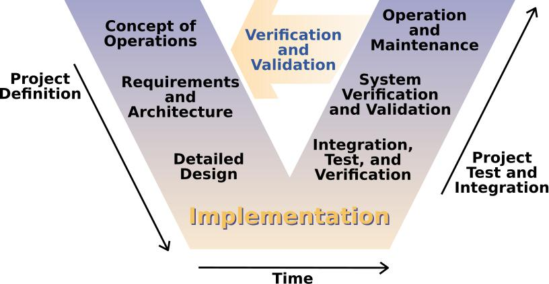

Fig. 2: V-Model Figure

**Requirements.**

In this stage the researchers will conduct a survey to gather data from students, instructors, and learners in the field of technology and under the course with programming subjects such as Bachelor of Science in Information Technology, Bachelor of Science in Computer Science, and Bachelor of Science in Computer Engineering as respondents. The data to be gathered (See APPENDIX A) will be evaluated and assessed to determine the knowledge and understanding of the respondents in regards to the fundamentals of pro-gramming, experience and feedback on traditional text-based tools and softwares. Prob-lems are identified and the Ishikawa Diagrams are constructed (See APPENDIX C).

**System Design.** The researchers will assess the gathered data and study the informationin order to construct a context diagram representing the manual way that the study will solve (See Context Diagram (Manual)). The schedule of the development and the allotted time for each is task is planned through the Gantt chart (See APPENDIX E).

**Architecture Design.**

The researchers in this stage will design and develop specifications that will serve as the blueprint of the software. The libraries, packages, tools, and more are will be finalized and prepared for later use (See Context Diagram).

**Module Design.**

31

The researchers will identify and define the scopes and specific features of each module and how will each be integrated along the system to work with other modules and components to ensure that each module is decoupled and can be tested without depen-dency in other module (See APPENDIX F).

**Implementation and Coding.**

The researchers will start to program each module, after each module pass the associated test, all will be coupled and integrated to a single system. The end product of this phase is the CodeNext: Visual Programming Software for Learning Fundamentals of Programming.

**Evaluation.**

The researchers will apply tests in the software that will be developed. Further testings will be done. Bugs, errors, and misbehaviors will be handled and fixed. The eval-uation to be used is the ISO/IEC/IEEE 29119-4:2015. The developers will test thoroughly the software and after that it will be tested by a wider group of testers to specifically evalu-ate the experience of the users. This evaluation will ensure that the functionality, efficiency, usability, portability, and reliability of the software meets the standard.

32

**REFERENCES**

Abe, K., Fukawa, Y., & Tanaka, T. (2019). Prototype of visual programming environment for c language novice programmer.

Abraham, R., Burnett, M., & Erwig, M. (2009). Spreadsheet programming.

Adelson, B., & Soloway, E. (1985). The role of domain expenence in software design. Alam, A., & Bush, V. (2016). Haskeu: An editor to support visual and textual programming

in tandem.

Aleryani, A. (2016). Comparative study between data flow diagram and use case diagram. Anggrawan, A., Ibrahim, N., M., S., & Satria, C. (2016). Influence of blended learning on

learning result of algorithm and programming.

Armoni, M., Meerbaum-Salant, O., & Ben-Ari, M. (2015). From scratch to “real” program-ming.

Bau, D., Gray, J., Kelleher, C., Sheldon, J., & Turbak, F. (2017). Learnable programming.

Cannasse, N. (2020). Haxe - the cross-platform toolkit. Retrieved from <https://haxe.org>

Carter, J., & Jenkins, T. (1999). Gender and programming: What’s going on?

Chang Boon Lee, P. (2011). Toward intuitive programming languages.

Cheng, E. (2016). Learning through the variation theory: A case study.

Coates, P. (2018). Haxe — the coolest language you’ve never heard of - dzone integration. Retrieved from <https://dzone.com/articles/haxe-the-coolest-language-youve-never-heard-of>

Coccia, M. (2017). The fishbone diagram to identify, systematize and analyze the sources of general purpose technologies.

Corney, M., Lister, R., & Teague, D. (2011). Early relational reasoning and the novice pro-grammer: Swapping as the "hello world" of relational reasoning.

Craft.ai, R. D. (2015). The maturity of visual programming. Retrieved from [https : / / www.](https://www.craft.ai/blog/the-maturity-of-visual-programming) [craft.ai/blog/the-maturity-of-visual-programming](https://www.craft.ai/blog/the-maturity-of-visual-programming)

DiSalvo, B. (2014). Graphical qualities of educational technology: Using drag-and-drop and text-based programs for introductory computer science.

Geraldi, J., & Lechter, T. (2012). Gantt charts revisited.

Harrison, W. (2004). From the editor: The dangers of end-user programming.

33

Hughes, R. (2016). Artifacts for the enterprise requirements value chain.

ISO/IEC JTC 1/SC 7 Software and systems engineering. (2015). ISO/IEC/IEEE 29119-4:2015 Software and systems engineering — Software testing — Part 4: Test tech-niques.

Joo, H. (2017). A study on understanding of ui and ux, and understanding of design ac-cording to user interface change.

Kaczmarczyk, L. C., Petrick, E. R., East, J. P., & Herman, G. L. (2010). Identifying student misconceptions of programming.

Ko, A. J., Myers, B. A., & Aung, H. H. (2004). Six learning barriers in end-user program-ming systems.

Linn, M. C., & Dalbey, J. (1985). Cognitive consequences of programming instruction: In-struction, access, and ability.

Lister, R. (2004). Teaching java first: Experiments with a pigs-early pedagogy.

Lister, R., Clear, T., Simon, Bouvier, D. J., Carter, P., Eckerdal, A., . . . Robbins, P. e. a.

(2009). Naturally occurring data as research instrument.

Liu, Y., Wu, L., & Dong, X. (2010). Research on controls-based visual programming. Maloney, J., Resnick, M., Rusk, N., Silverman, B., & Eastmond, E. (2010). The scratch

programming language and environment.

McCracken, M., Almstrum, V., Diaz, D., Guzdial, M., Hagan, D., Kolikant, Y. B.-D., . . . Wilusz, T. (2001). A multi-national, multi-institutional study of assessment of programming skills of first-year cs students.

Norman, D. (2013). The design of everyday things.

Ottosson, S., & Zaslavskyi, V. (2019). Visualize what to be coded before programming.

Ousterhout, J. (1998). Scripting: Higher level programming for the 21st century.

Prahofer, H., Hurnaus, D., Wirth, C., & Mossenbock, H. (2007). The domain-specific lan-

guage monaco and its visual interactive programming environment. Prokhorov, V., & Kosarev, V. (1999). Environment pij for visual programming in java. Raiyn, J. (2020). The role of visual learning in improving students’ high-order thinking

skills.

Raja, R., & Nagasubramani, P. C. (2018). Impact of modern technology in education. Repenning, A. (2017). Moving beyond syntax: Lessons from 20 years of blocks program-

ming in agentsheets.

34

Robins, A., Rountree, J., & Rountree, N. (2003). Learning and teaching programming: A review and discussion.

Rook, P. (1986). Controlling software projects.

Saito, D., Washizaki, H., & Fukazawa, Y. (2017). Analysis of the learning effects between text-based and visual-based beginner programming environments.

Sorva, J. (2012). Visual program simulation in introductory programming education. Tan, P., Ting, C., & Ling, S. (2009). Learning difficulties in programming courses: Under-

graduates’ perspective and perception.

Thompson, D. V., Hamilton, R. W., & Rust, R. T. (2005). Feature fatigue: When product capabilities become too much of a good thing.

Tsai, C.-Y., Yang, Y.-F., & Chang, C.-K. (2015). Cognitive load comparison of traditional and distributed pair programming on visual programming language.

Tsukamoto, H., Takemura, Y., Oomori, Y., Ikeda, I., Nagumo, H., Monden, A., & Matsumoto, K.-i. (2016). Textual vs. visual programming languages in programming education for primary schoolchildren.

Williams, C., Alafghani, E., Daley, A., Gregory, K., & Rydzewski, M. (2015). Teaching pro-gramming concepts to elementary students.

Zhang, D.-Q., & Zhang, K. (n.d.). On the design of a generic visual programming environ-ment.

35

**APPENDICES**

**APPENDIX A**

**Form A**

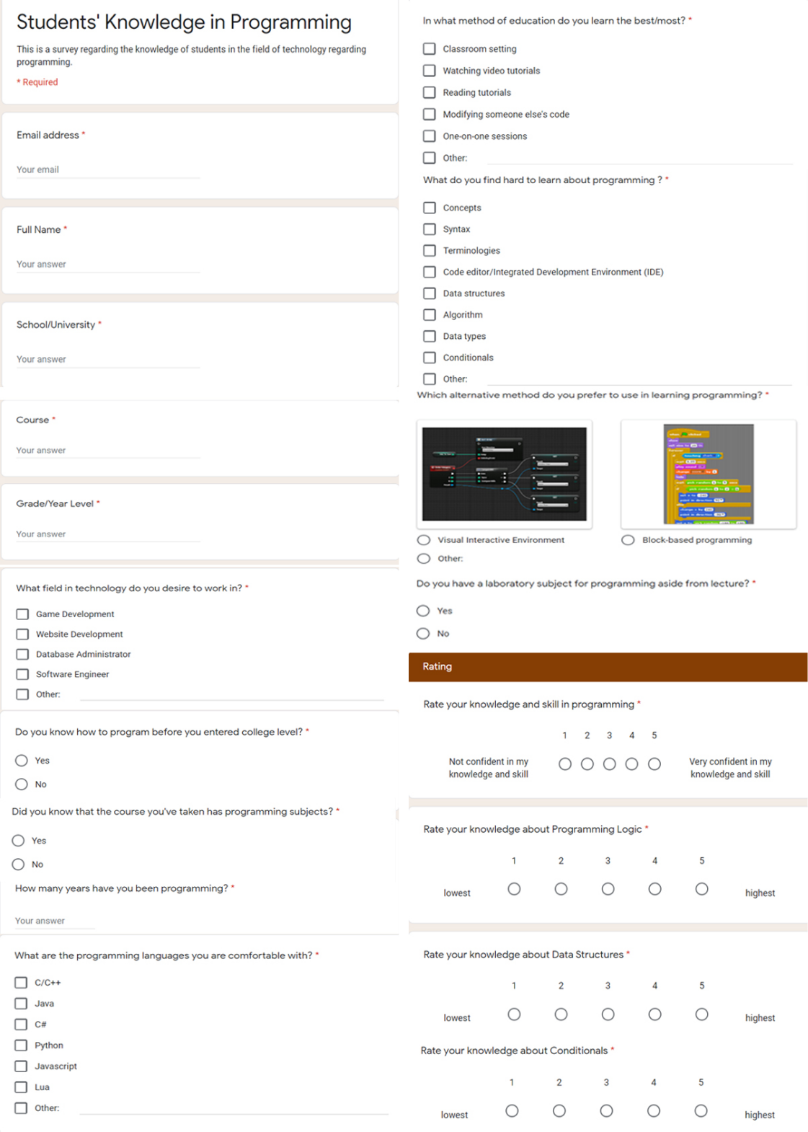

36

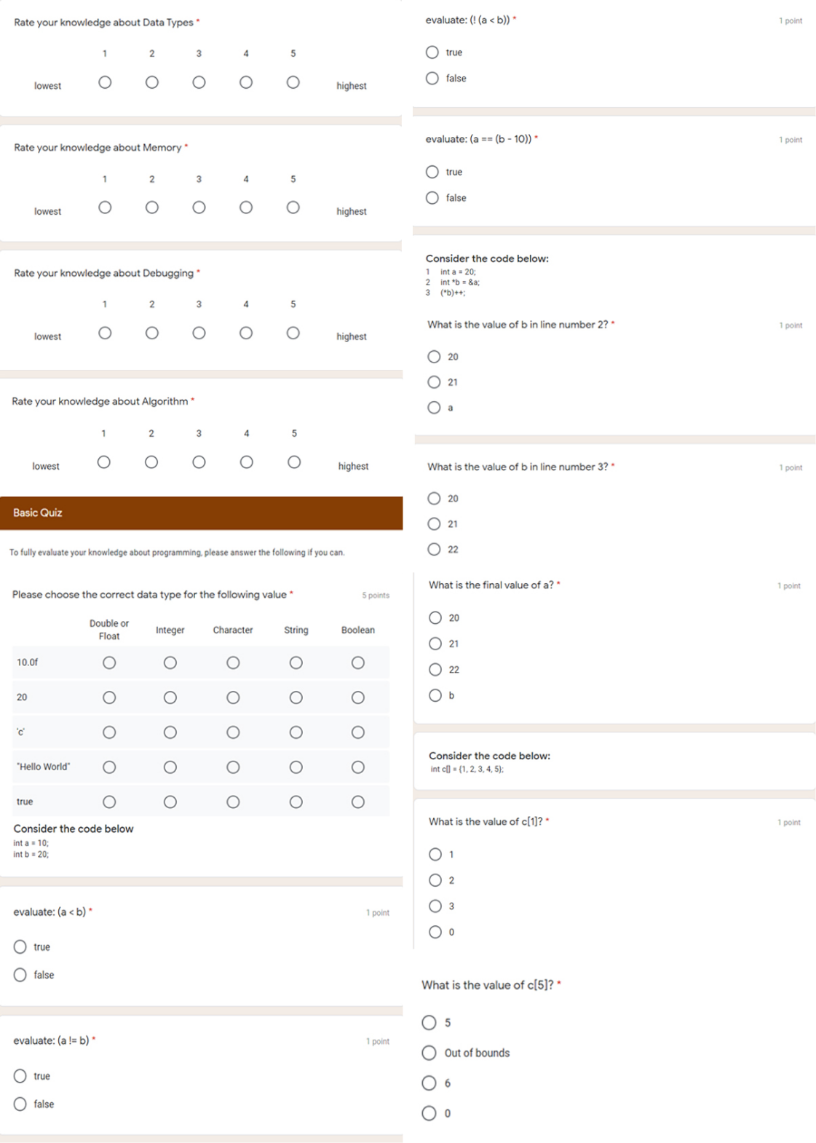

37

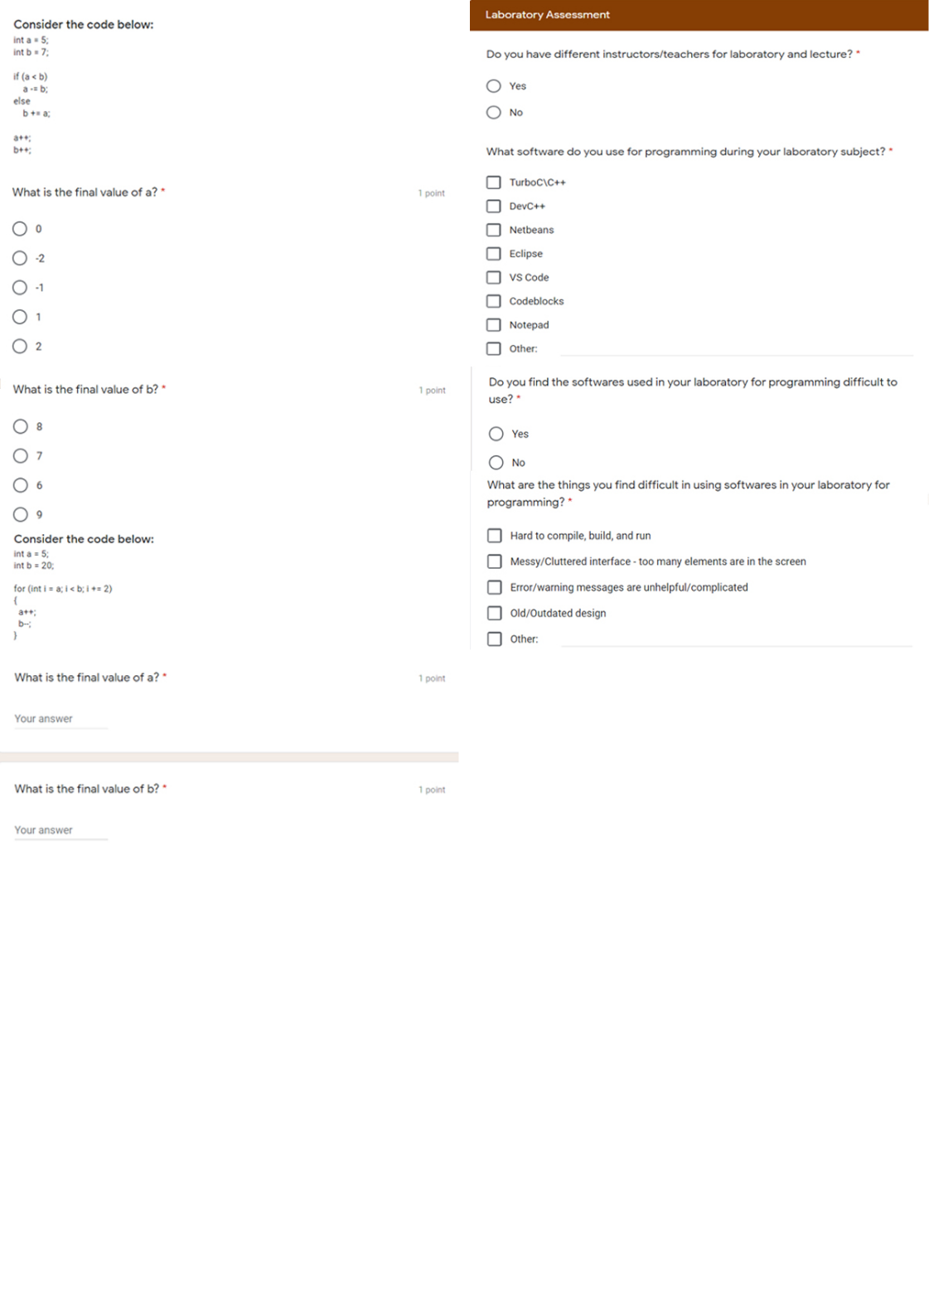

38

**Form B**

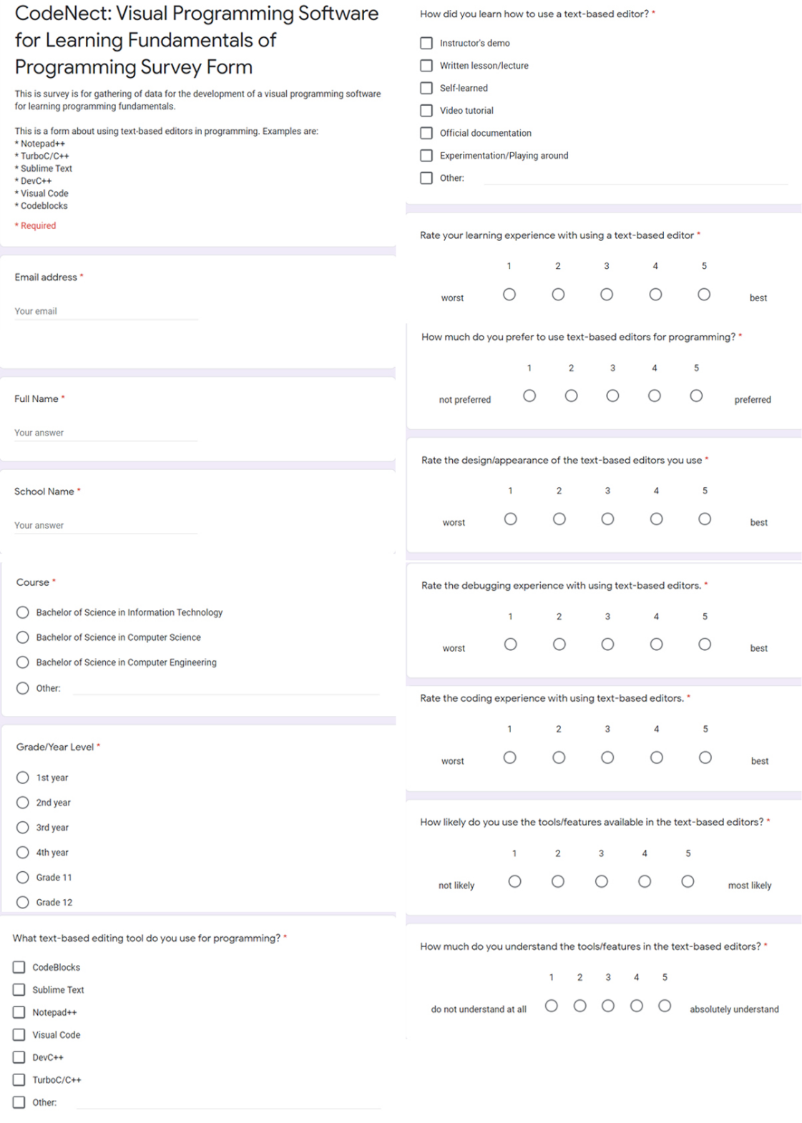

39

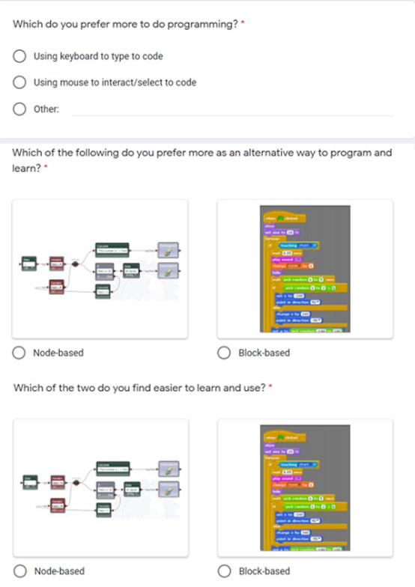

40

**APPENDIX B**

**Graphical Results**

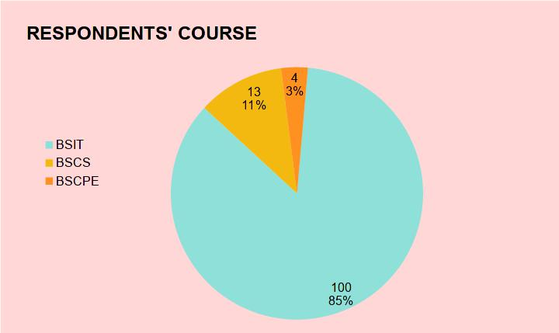

Fig. 3: Respondents’ Course

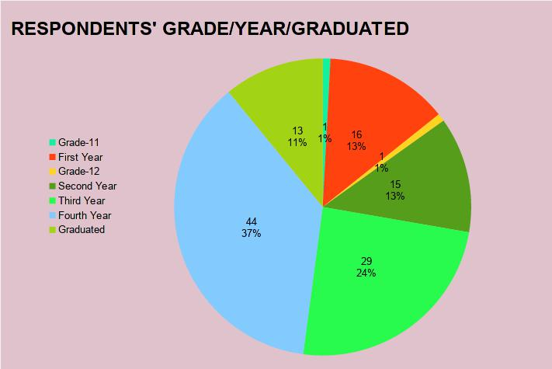

Fig. 4: Respondents’ Grade/Year Level

41

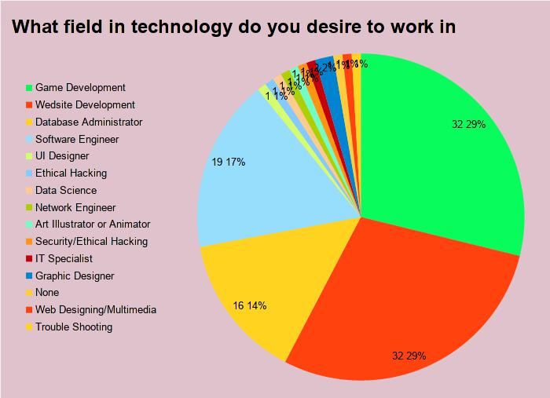

Fig. 5: Desired technology field to Work in

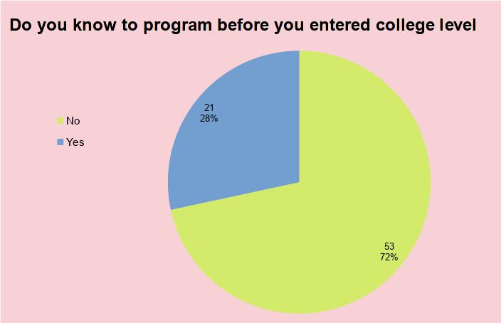

Fig. 6: Known programming before Entering College

42

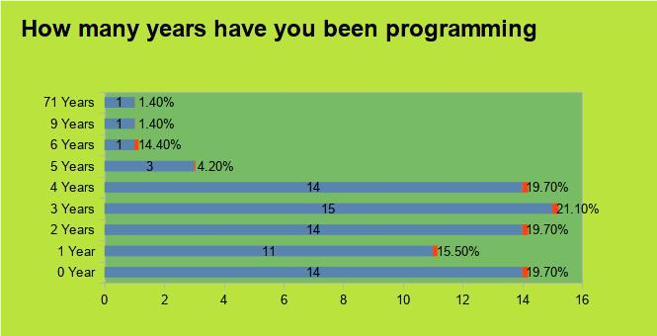

Fig. 7: Number of Years Programming

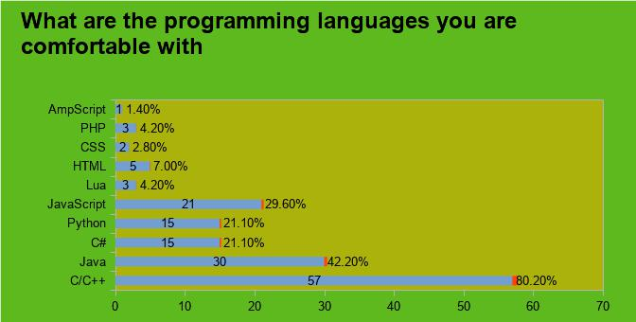

Fig. 8: Programming Languages Comfortable With

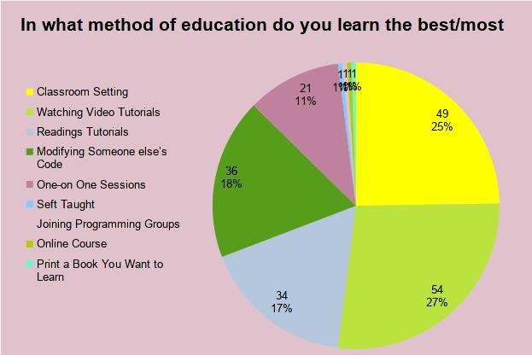

Fig. 9: Method of Education

43

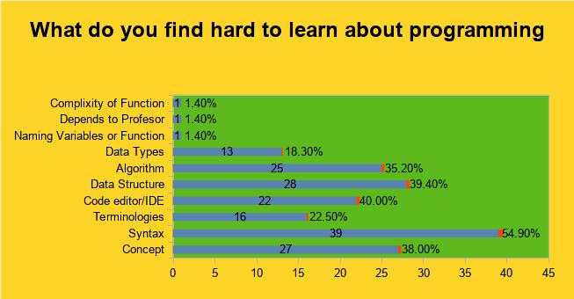

Fig. 10: Hard to Learn in Programming

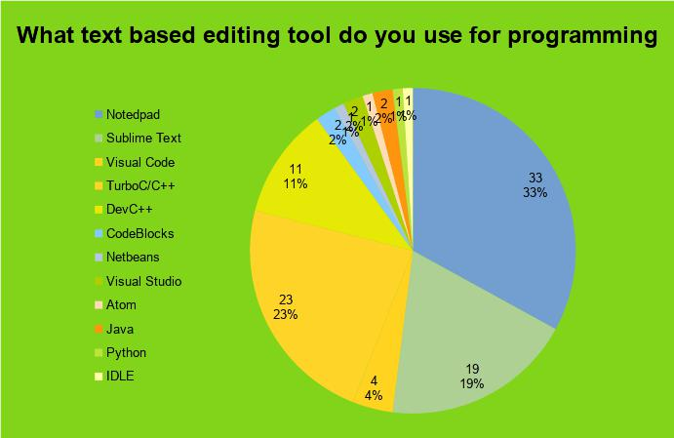

Fig. 11: Text-based Editing Tool Used

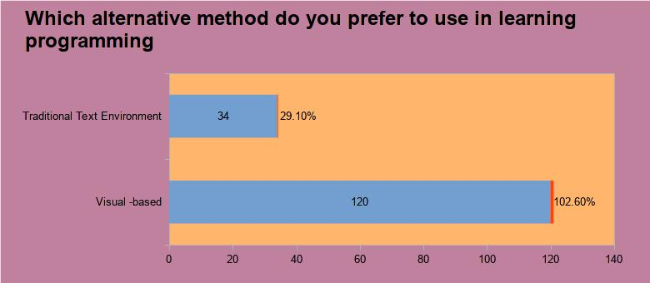

Fig. 12: Alternative Method

44

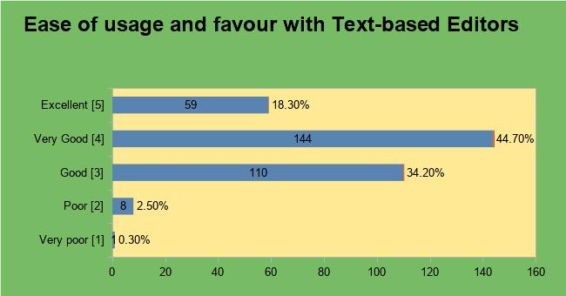

Fig. 13: Ease of Usage with Text-based Editors

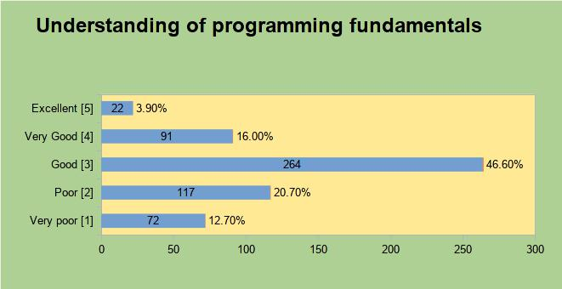

Fig. 14: Understanding Programming Fundamentals

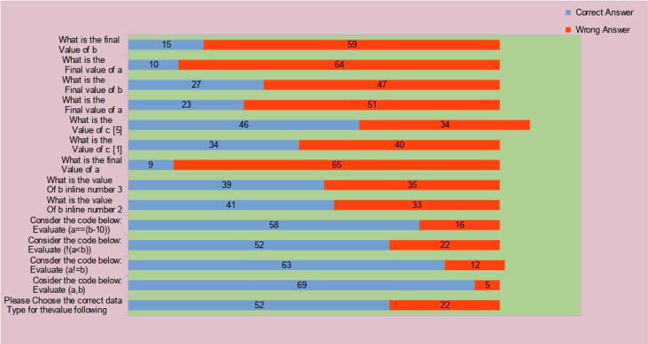

Fig. 15: Respondents’ Programming Knowledge Assessment

45

**APPENDIX C**

**Ishikawa Diagrams**

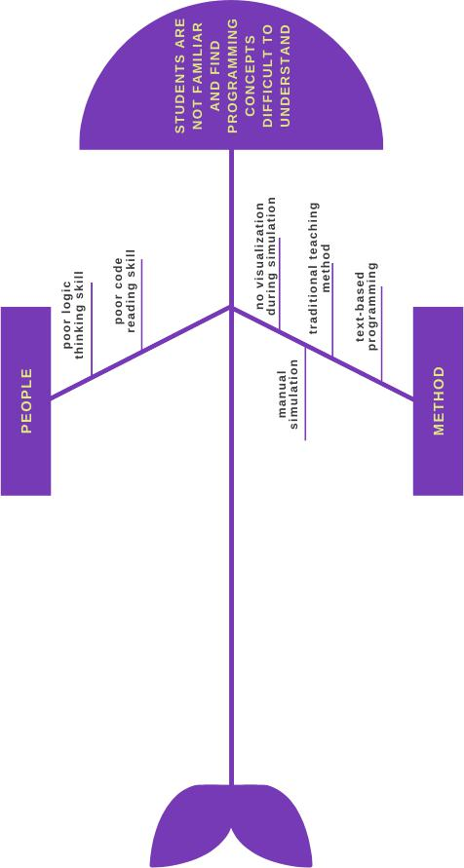

Fig. 16: Students are not familiar and find programming concepts difficult to understand

46

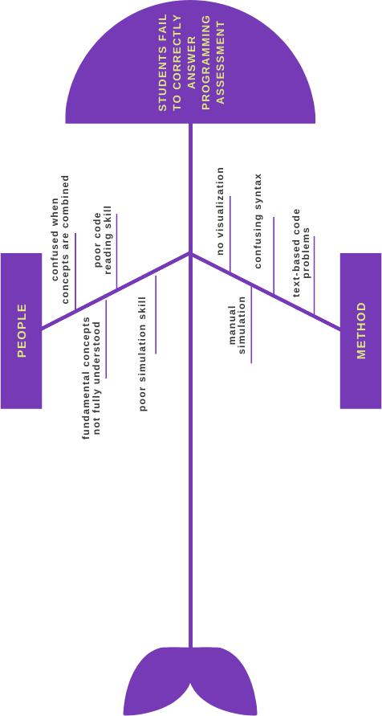

Fig. 17: Students fail to correctly answer programming assessment

47

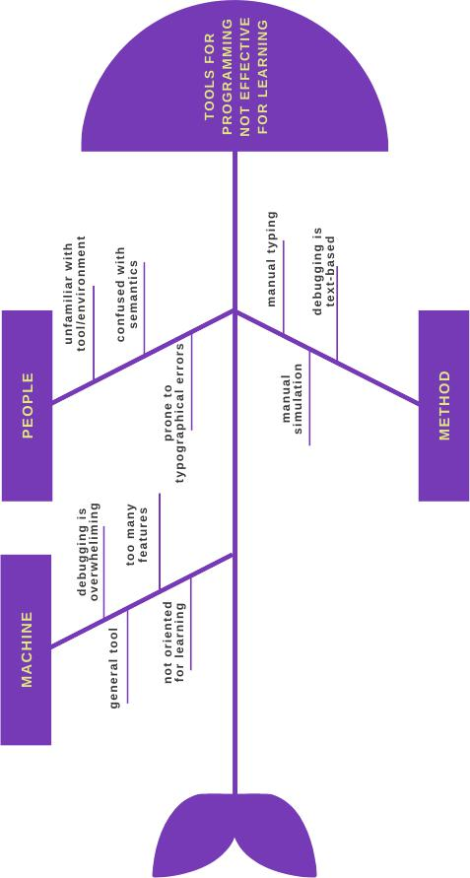

Fig. 18: Tool for programming not effective for learning

48

**APPENDIX D**

**Context Diagram (Manual)**

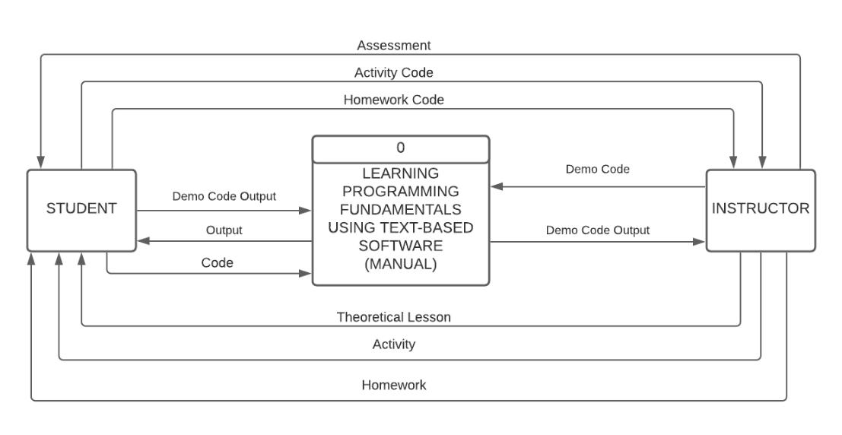

Fig. 19: Context Diagram of Existing System

**Context Diagram**

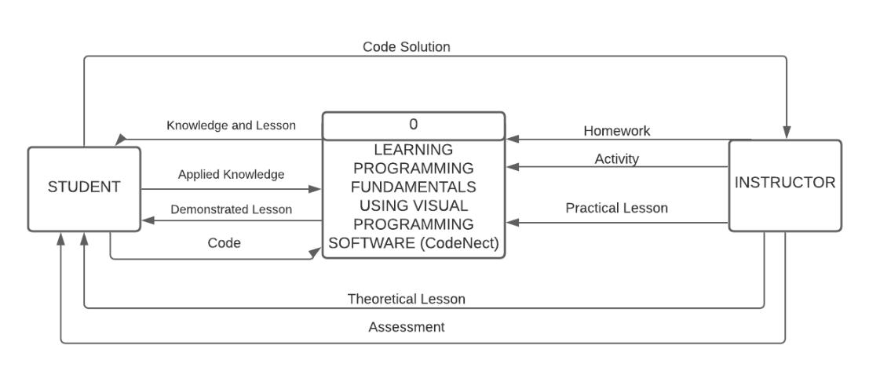

Fig. 20: Context Diagram of Proposed System

49

**APPENDIX E**

**Gantt Chart**

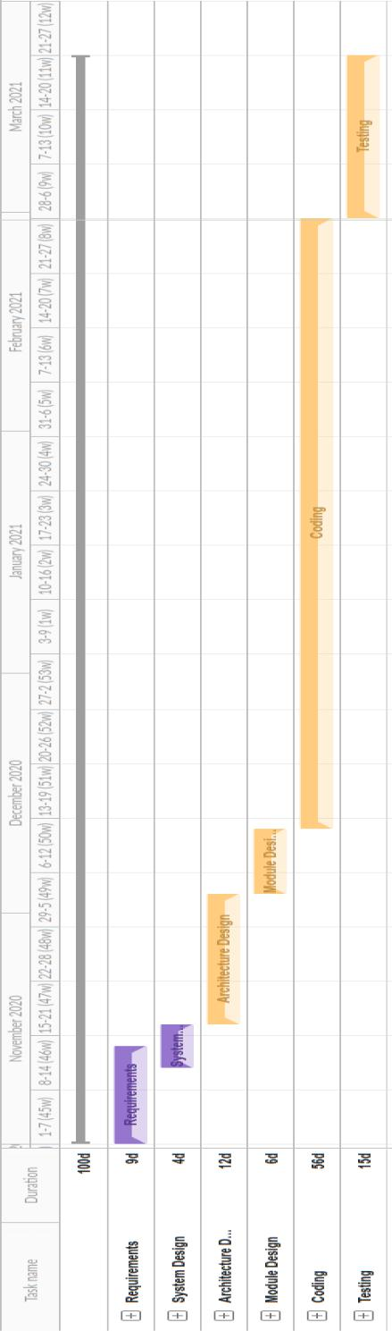

Fig. 21: Gantt Chart of the Development of CodeNect

50

**APPENDIX F**

**Theoretical Framework**

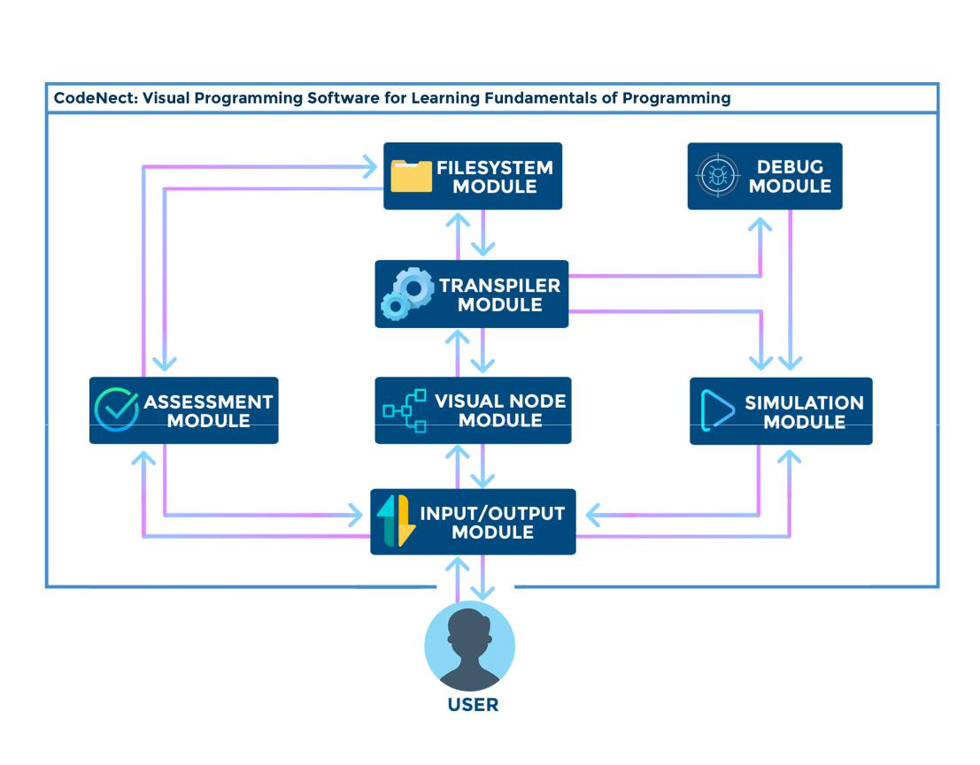

Fig. 22: Theoretical Framework of CodeNect: Visual Programming Software for Learning Fundamentals of Programming